Project
  - Phase1 - Deadline: Sunday 26/07/2026 @ 23:59 Phase2 – Deadline: Sunday 09/08/2026 @ 23:59
[Total Mark is 20]

Web Programming
IT361

Student Details: CRN:
Name:  Name:  Name:  Name: |  | ID:  ID:  ID:  ID:

Instructions:
- You must submit two separate copies (one Word file and one PDF file) using the Assignment Template on Blackboard via the allocated folder. These files must not be in compressed format.
- It is your responsibility to check and make sure that you have uploaded both the correct files.
- Zero mark will be given if you try to bypass the SafeAssign (e.g. misspell words, remove spaces between words, hide characters, use different character sets, convert text into image or languages other than English or any kind of manipulation).
- Email submission will not be accepted.
- You are advised to make your work clear and well-presented. This includes filling your information on the cover page.
- You must use this template, failing which will result in zero mark.
- You MUST show all your work, and text must not be converted into an image, unless specified otherwise by the question.
- Late submission will result in ZERO mark.
- The work should be your own, copying from students or other resources will result in ZERO mark.
- Use Times New Roman font for all your answers.

Description and Instructions
Learning Outcome (1, 2,3, 5,6):
Describe methods and tools in web development.
Create web pages using HTML5 and CSS3.
Develop dynamic web pages using JavaScript.
Create Rich Internet Applications.
Build web applications using PHP and MySQL.

Project Idea: “Campus Events Hub”
Each group will design and build a small dynamic website for a fictional university club or department that publishes upcoming campus events (workshops, seminars, competitions, trips) and lets students register for them online. The site is built with HTML and CSS for the front end, and basic PHP for the dynamic parts (page templates, form handling, validation, and saving registrations).
Group size: 3–4 students. Duration: 6 weeks.

Functional Requirements (Minimum)
The website must contain at least the following pages:
- Home page: introduction to the club/department and highlights of the next 3 upcoming events.
- Events page: a list of all events, generated by PHP from a data source (PHP array, text/CSV file, or a simple database table — the group chooses).
- Event details page: one page that displays the details of a selected event (using a GET parameter, e.g. event.php?id=3).
- Registration page: an HTML form (name, student ID, email, selected event) processed by PHP with server-side validation; valid registrations are appended to a text/CSV file or database table, and a confirmation message is shown.
- Registrations list page: a page that reads the stored registrations and displays them in an HTML table.
- About / Contact page: team members and a simple contact form (validation only; no email sending required).

Technical Requirements

HTML
- Valid, semantic markup (header, nav, main, section, footer); correct use of headings, lists, tables, images, and links.
- At least one data table and at least two forms with appropriate input types and labels.

CSS
- One shared external stylesheet (no inline styles except where justified).
- A consistent color scheme and typography, a styled navigation bar, and hover/focus states.
- A basic responsive behavior (e.g., layout adapts on small screens using media queries or flexible units).

PHP
- Shared header and footer using include/require on every page.
- Handling of GET and POST data with server-side validation (required fields, email format, etc.) and clear error messages.
- Reading and writing data (text/CSV file or a simple database table) and displaying it with loops.
- Code is organized, indented, and commented; no frameworks or site builders are allowed.
Timeline
- Week 1: team formation, choosing the club theme, sitemap and page sketches.
- Weeks 2–3: static HTML/CSS version of all pages.
- Week 3 (end): submit the mid-project progress report.
- Weeks 4–5: PHP work: templates, forms, validation, data storage and display.
- Week 6: testing, polishing, final report, and submission.

Submission Guidelines and Instructions

1. Mid-Project Progress Report
Each group must submit a short progress report at the end of Week 3, which must include:
- Work completed this period.
- One key decision made during this period.
- One problem encountered.
- Plan for the next period.
- Each group member's input/participation.

2. Weekly Progress Log (Inside the Submission File)
Students must document their progress inside the final submission file itself, in a dedicated section named “Progress Log”. The log must contain one dated entry per week (minimum 5 entries) written at the time of the work, not at the end. Each weekly entry must include:
- Date and week number.
- What was accomplished that week (2–4 sentences).
- Which member did what.
- At least one screenshot of the website or code as it looked that week (screenshots must show a visible date/timestamp, e.g., the system clock or file properties).
What NOT to do: Students must not build the entire project at the last minute and then write the log retroactively. Entries that all look written in one sitting, screenshots without dates, or a log that does not match the final work are treated as red flags regardless of the quality of the final website.

3. Project Artifacts
A separate section in the final report must be named “Project Artifacts” and must include:
- The full source code of the website as a ZIP file (all .html, .css, .php files, images, and any data files), submitted together with the report.
- A short “How to run” note (e.g., which folder to place in XAMPP/htdocs and which page to open first).
- The Progress Log section described above, with its screenshots.

4. Written Reflection (End-of-Project Report)
The final report must end with a Reflection section (300–500 words), written in the students' own words, addressing some of the following:
- Describe one specific challenge or obstacle you encountered during this project and explain in detail how you identified and resolved it.
- Explain why you chose your specific approach (e.g., CSV file vs. database, page layout technique) over at least one alternative you considered, and what tradeoffs informed that decision.
- If you used any AI tools during this project (e.g., ChatGPT, Claude, Copilot), disclose which tool(s), for what specific purpose (e.g., debugging, grammar checking, brainstorming), and how you verified or modified the output.
- What would you do differently if you were to redo this project with more time or resources?
This section will be evaluated for specificity and consistency with the technical content of the project report.
Important Notes
- AI use: Students may use AI tools (ChatGPT, Claude, Copilot, Gemini, etc.) only for brainstorming approaches, debugging small errors, or proofreading text. AI must not be used to generate the code logic or produce substantial portions of the report or website. Any permitted AI use must be disclosed in the Reflection section. Undisclosed AI use, or AI use beyond this scope (disclosed or not), will result in a zero grade for the entire project.
- Any submission lacking a valid, inspectable Progress Log, or showing evidence of AI generation or plagiarism, will receive a zero grade for the entire project.
- Failure to submit the mid-project progress report as required, or submission of reports found to be fabricated, copied, or AI-generated, will result in a zero grade for the entire project.

Progress Log
Week 1 – 15 July 2026
The group held its first meeting and selected the project concept, “Saudi Campus Connect,” for the Saudi Student Enrichment Center. We reviewed the required pages, prepared the initial sitemap, and agreed on the main visual direction, including the green, cream, and brown color scheme. We also divided the first-stage responsibilities among the members.
Mohammed Maashi prepared the homepage plan and suggested the main content sections. Bader Alshehri drafted the initial color scheme and page-layout ideas. Faris Faden listed the required registration and contact form fields. Adnan Alotaibi reviewed the data requirements and identified the activities, participants, and inquiries tables needed later.
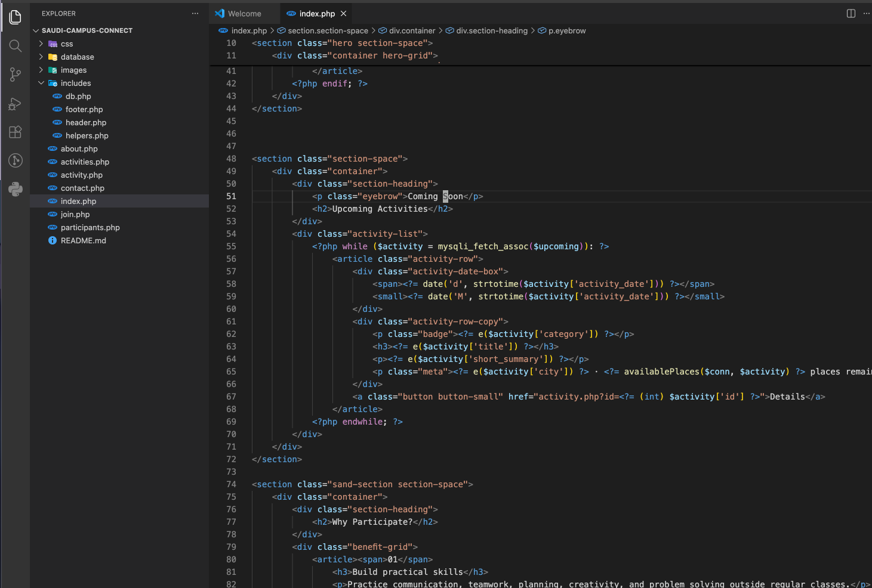
Week 2 – 22 July 2026
The group created the first static versions of the Home, Activities, About, and Contact pages using semantic HTML5. A shared navigation bar and footer were added, and sample activity content was placed on the pages to test the layout. At this stage, the pages were not connected to PHP or MySQL.
Mohammed Maashi developed the homepage content and activity descriptions. Bader Alshehri created the external CSS file and styled the navigation bar, headings, buttons, and page sections. Faris Faden prepared the HTML structures for the registration and contact forms. Adnan Alotaibi checked page links, filenames, and the planned database fields.
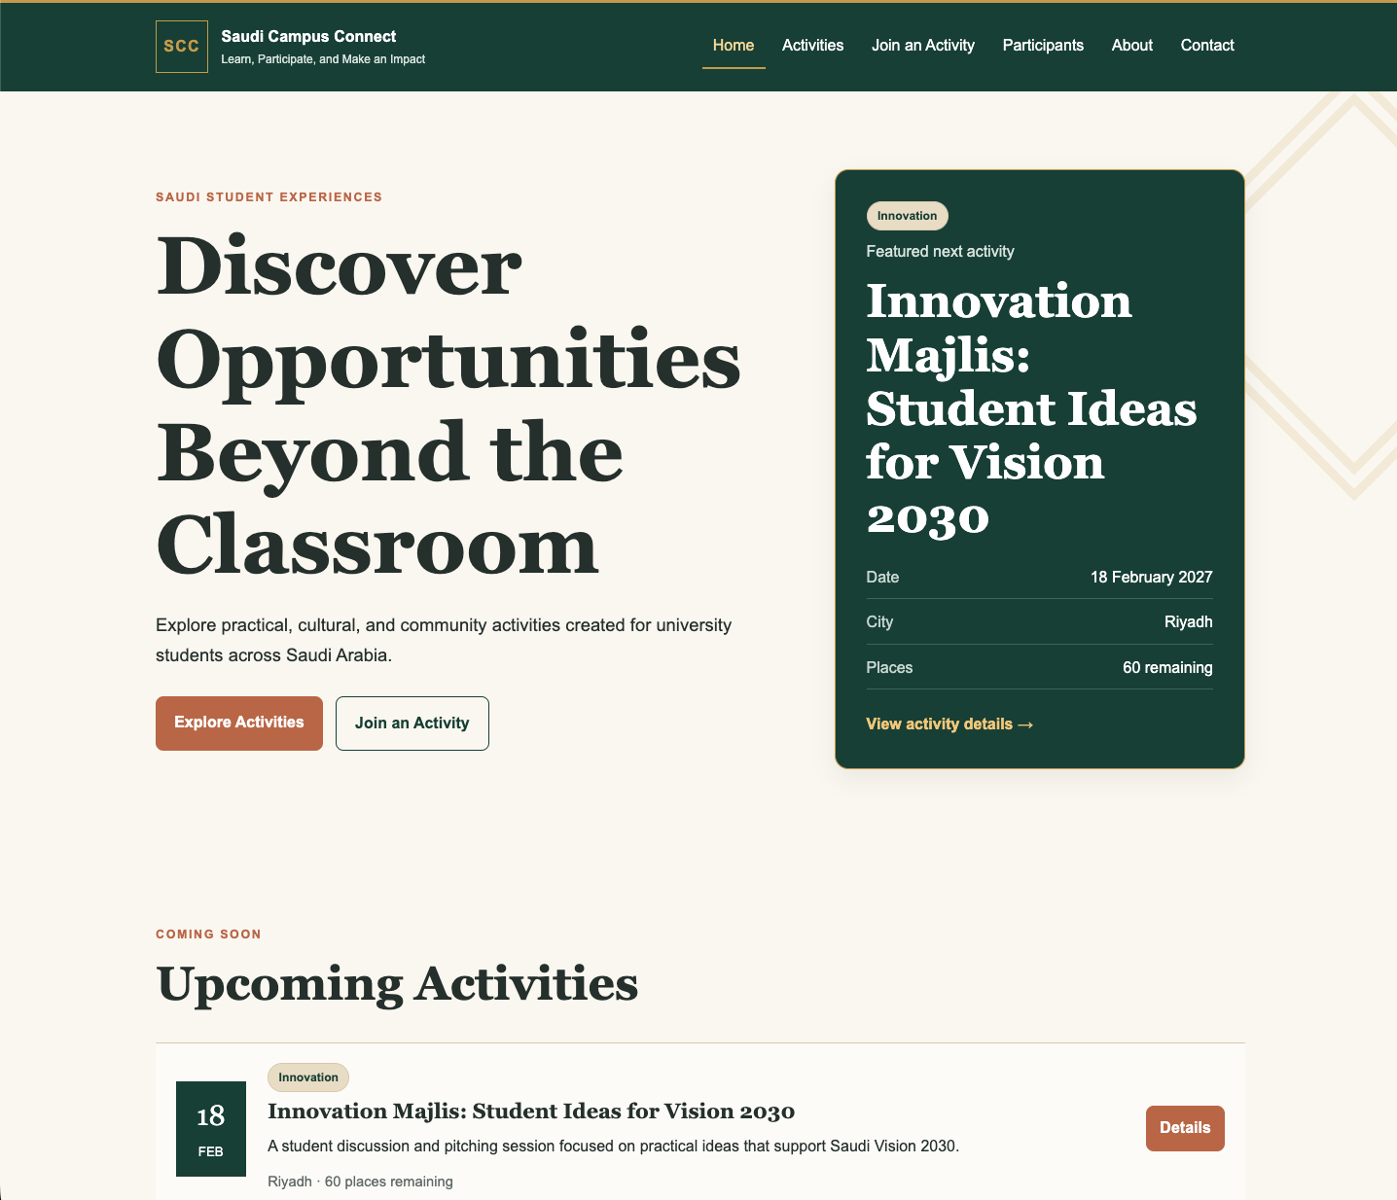
Week 3 – 29 July 2026
The group completed the main static interface and reviewed the pages for consistency. Responsive rules were added so that activity cards, forms, navigation elements, and content sections could adapt to smaller screens. The team also finalized the decision to use MySQL rather than CSV files because the project required organized relationships between activities and registrations.
Mohammed Maashi revised the page content and checked the homepage structure. Bader Alshehri improved spacing, typography, responsive layouts, and hover effects. Faris Faden reviewed the form labels and planned the server-side validation rules. Adnan Alotaibi designed the database structure and prepared the initial SQL tables.
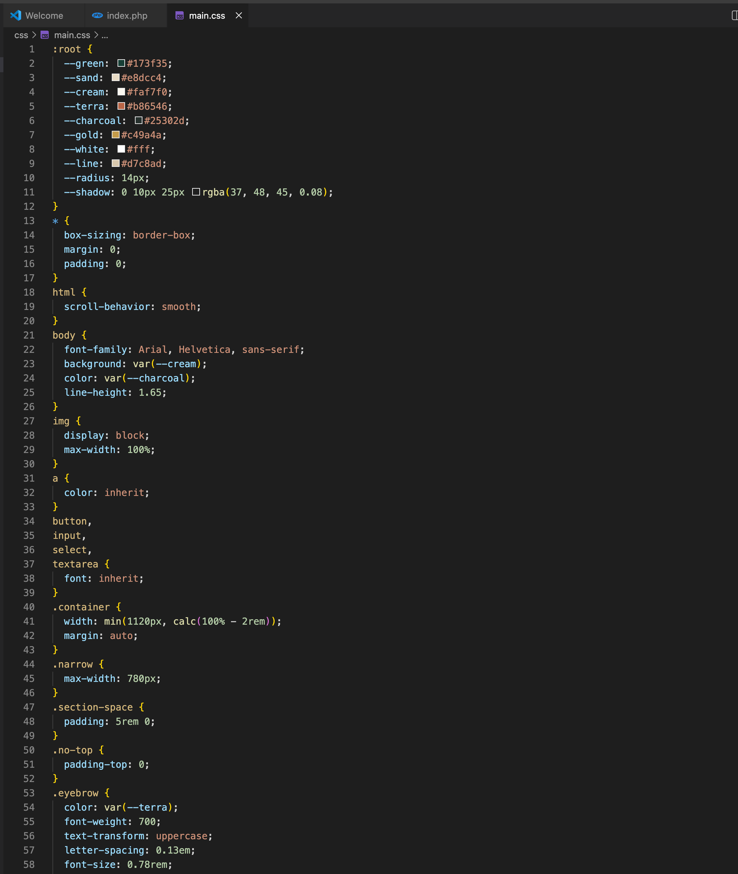
Week 4 – 2 August 2026
The group began converting the static website into dynamic PHP pages. Shared header and footer files were created and included across the website. The activities page was connected to MySQL, and individual activity information was displayed through a GET parameter using the activity ID.
Mohammed Maashi checked the dynamic content displayed on the Home and Activities pages. Bader Alshehri adjusted the CSS after the PHP sections replaced the static content. Faris Faden worked on PHP form processing and initial validation messages. Adnan Alotaibi created the database connection, inserted sample activity records, and tested SQL queries.
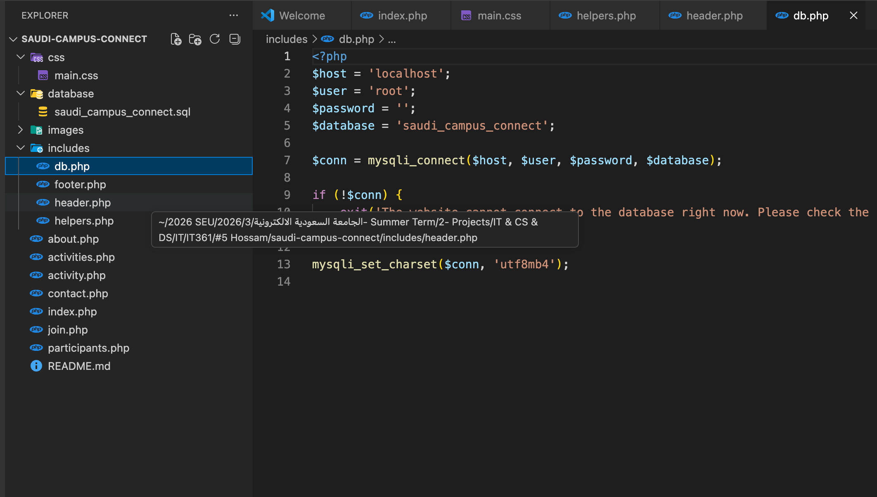

Week 5 – 6 August 2026
The registration and contact forms were connected to the database using MySQLi prepared statements. Server-side validation was added for student names, university IDs, email addresses, Saudi mobile numbers, activity selection, agreement confirmation, inquiry types, and message length. The group also implemented duplicate-registration checking and activity-capacity checking.
Mohammed Maashi reviewed confirmation and error messages to ensure they were understandable. Bader Alshehri styled the success messages, validation errors, form fields, and participant table. Faris Faden developed the validation logic and tested valid and invalid form submissions. Adnan Alotaibi implemented the insert queries, duplicate checks, capacity calculation, and participant-registration query using an SQL INNER JOIN.
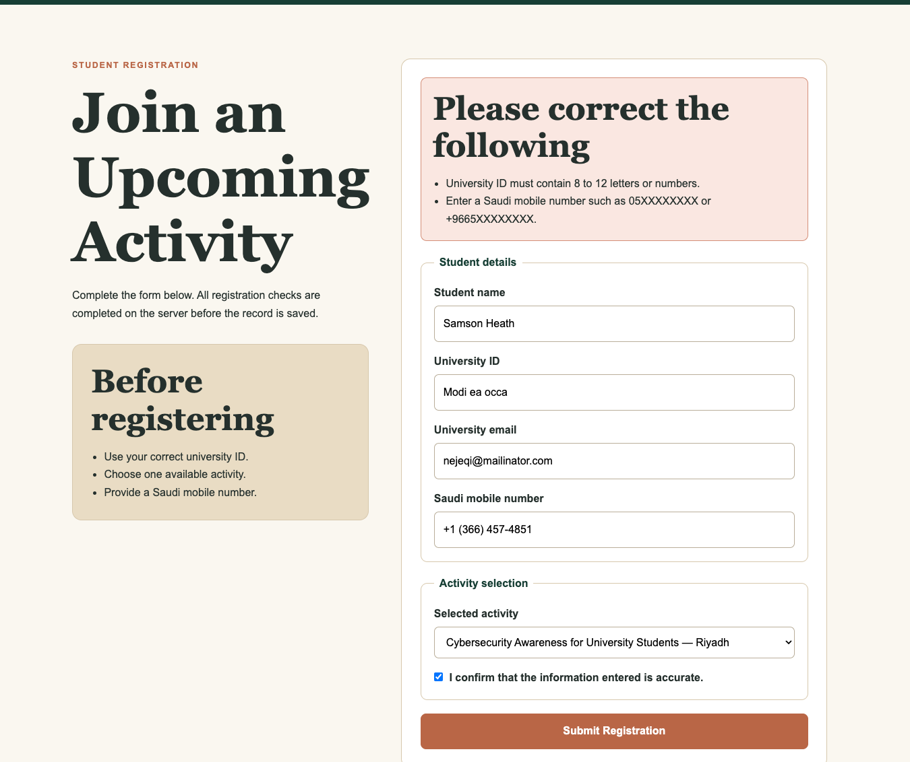
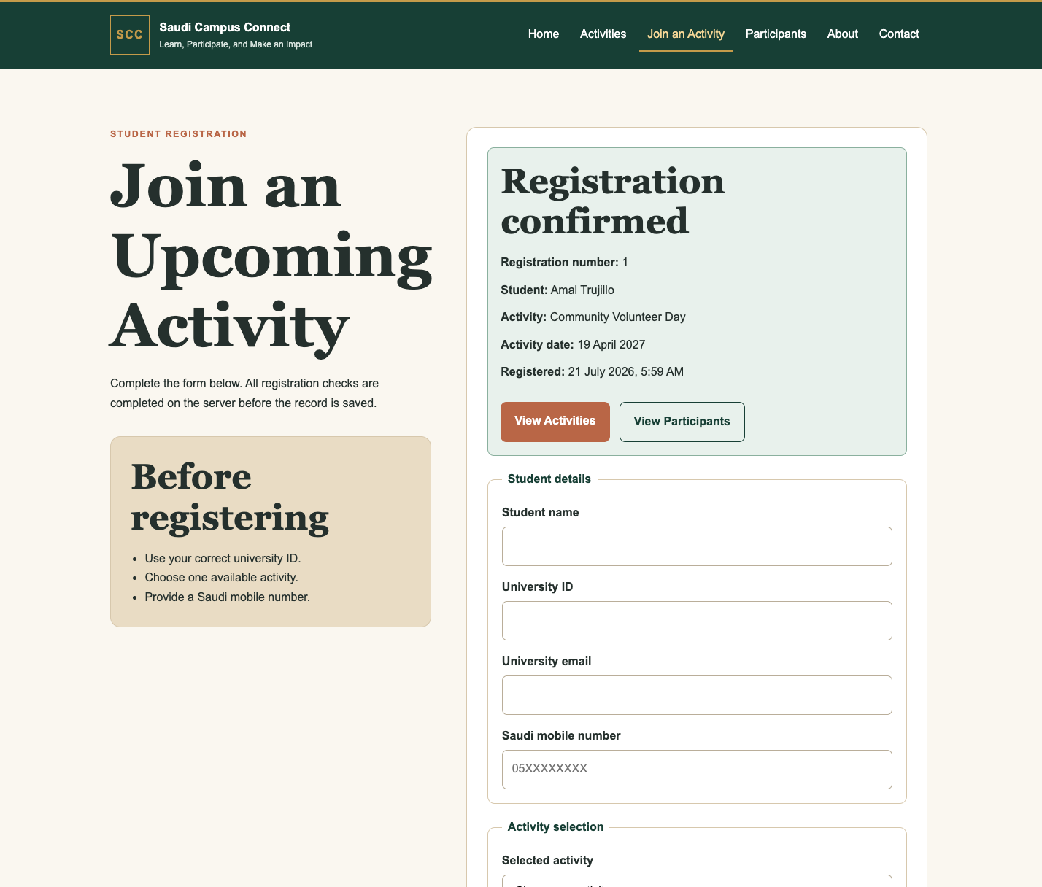
Week 6 – 9 August 2026
The group completed final testing and prepared the project for submission. All page links, GET parameters, forms, database queries, responsive layouts, and confirmation messages were checked. The team also reviewed the source-code folder, prepared the “How to Run” instructions, completed the report sections, and confirmed that the Word, PDF, and ZIP files contained the correct work.
Mohammed Maashi reviewed the final website content and report structure. Bader Alshehri completed the last visual and responsive corrections. Faris Faden retested the forms and corrected minor validation issues. Adnan Alotaibi checked the database import file, participant records, and final project setup. All members jointly reviewed the final submission for consistency.

